Name: Aadarsh Venkatesh Nandedkar
PRN: 22510047
High Performance Computing Lab
Practical No. 10

Title of practical: Understanding concepts of CUDA Programming

Problem Statement 1:
Execute the following program and check the properties of your GPGPU.

#include <stdio.h>
#include <stdlib.h>
int main()
{
int deviceCount;
cudaGetDeviceCount(&deviceCount);
if (deviceCount == 0)
{
printf("There is no device supporting CUDA\n");
}
int dev;
for (dev = 0; dev < deviceCount; ++dev)
{
cudaDeviceProp deviceProp;
cudaGetDeviceProperties(&deviceProp, dev);
if (dev == 0)
{
if (deviceProp.major < 1)
{
printf("There is no device supporting CUDA.\n");
}
else if (deviceCount == 1)
{
printf("There is 1 device supporting CUDA\n");
}
else
{
printf("There are %d devices supporting CUDA\n", deviceCount);
}
}
printf("\nDevice %d: \"%s\"\n", dev, deviceProp.name);
printf(" Major revision number: %d\n", deviceProp.major);
printf(" Minor revision number: %d\n", deviceProp.minor);
printf(" Total amount of global memory: %d bytes\n", deviceProp.totalGlobalMem);
printf(" Total amount of constant memory: %d bytes\n", deviceProp.totalConstMem);
printf(" Total amount of shared memory per block: %d bytes\n", deviceProp.sharedMemPerBlock);
printf(" Total number of registers available per block: %d\n", deviceProp.regsPerBlock);
printf(" Warp size: %d\n", deviceProp.warpSize);
printf(" Multiprocessor count: %d\n",deviceProp.multiProcessorCount );

printf(" Maximum number of threads per block: %d\n", deviceProp.maxThreadsPerBlock);
printf(" Maximum sizes of each dimension of a block: %d x %d x %d\n", deviceProp.maxThreadsDim[0],deviceProp.maxThreadsDim[1], deviceProp.maxThreadsDim[2]);
printf(" Maximum sizes of each dimension of a grid: %d x %d x %d\n", deviceProp.maxGridSize[0], deviceProp.maxGridSize[1], deviceProp.maxGridSize[2]);
printf(" Maximum memory pitch: %d bytes\n", deviceProp.memPitch);
printf(" Texture alignment: %d bytes\n", deviceProp.textureAlignment);
printf(" Clock rate: %d kilohertz\n", deviceProp.clockRate);
}
}
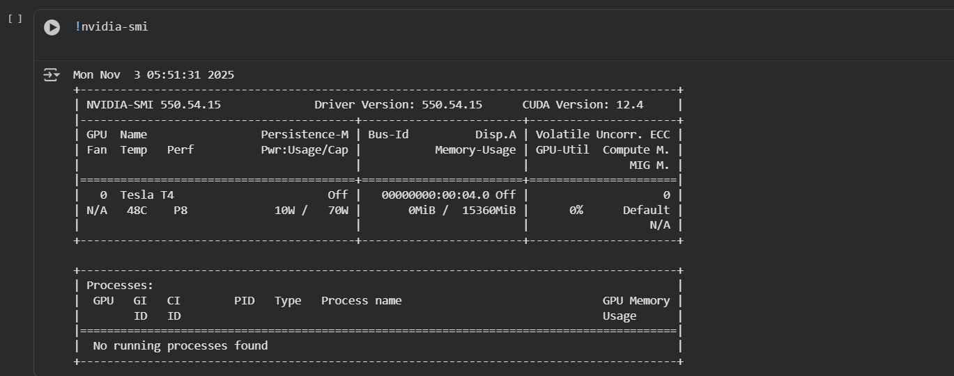
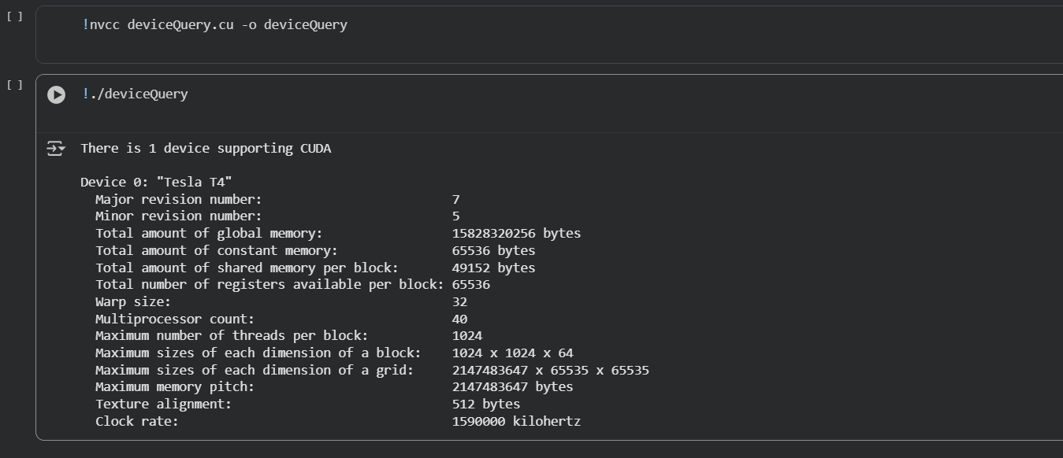

Problem Statement 2:

Write a program to where each thread prints its thread ID along with hello world. Lauch the kernel with one block and multiple threads.
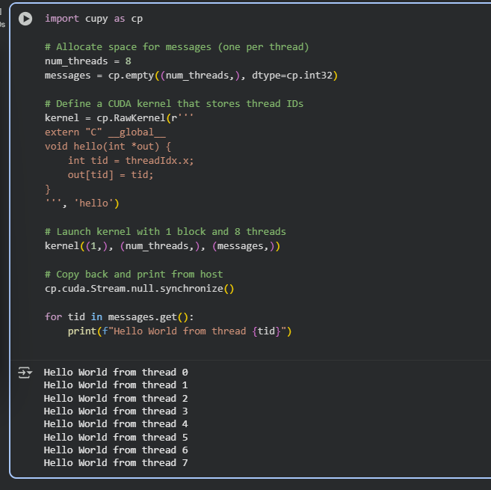
Problem Statement 3:

Write a program to where each thread prints its thread ID along with hello world. Lauch the kernel with multiple blocks and multiple threads.
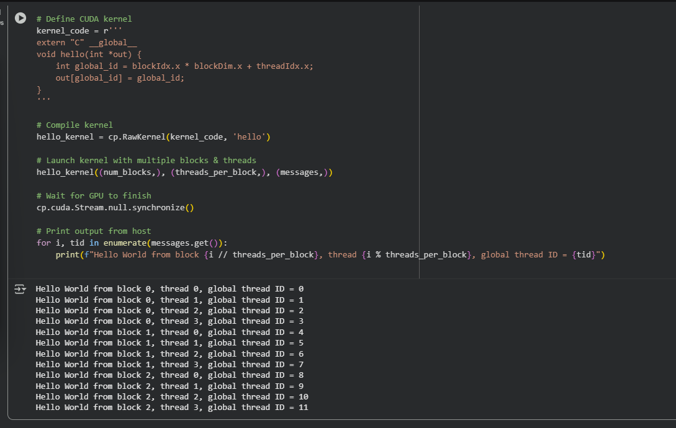Problem Statement 4:

Write a program to where each thread prints its thread ID along with hello world. Lauch the kernel with 2D blocks and 2D threads.
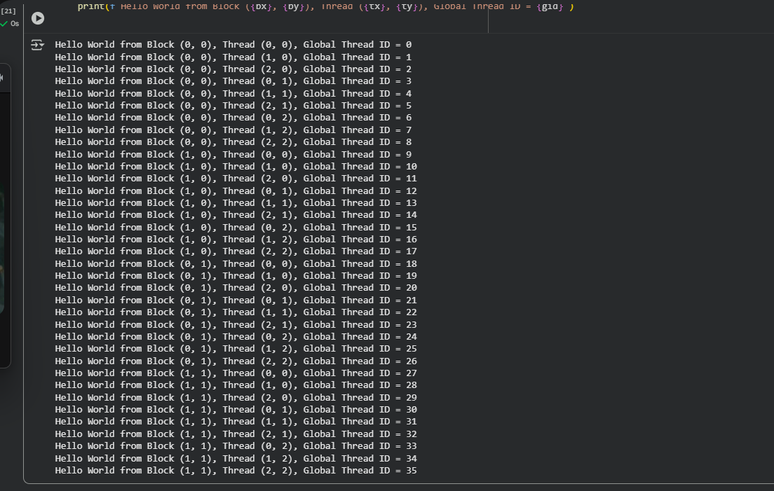
Problem statement 5: Vector Addition using CUDA
Problem Statement: Write a CUDA C program that performs element-wise addition of two vectors A and B of size N. The result of the addition should be stored in vector C.
Details:
• Initialize the vectors A and B with random numbers.
• The output vector C[i] = A[i] + B[i], where i ranges from 0 to N-1.
• Use CUDA kernels to perform the computation in parallel.
• Write the code for both serial (CPU-based) and parallel (CUDA-based) implementations.
• Measure the execution time of both the serial and CUDA implementations for different values of N (e.g., N = 10^5, 10^6, 10^7).
Task:
• Calculate and report the speedup (i.e., the ratio of CPU execution time to GPU execution time).
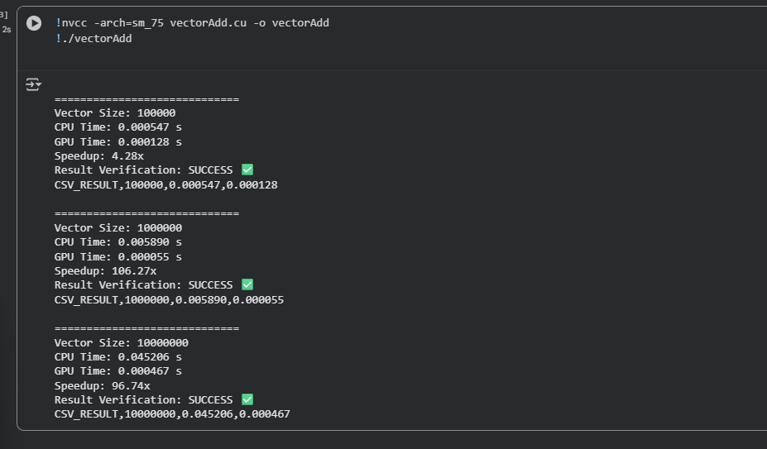
________________________________________
Problem statement 6: Matrix Addition using CUDA
Problem Statement: Write a CUDA C program to perform element-wise addition of two matrices A and B of size M x N. The result of the addition should be stored in matrix C.
Details:
• Initialize the matrices A and B with random values.
• The output matrix C[i][j] = A[i][j] + B[i][j] where i ranges from 0 to M-1 and j ranges from 0 to N-1.
• Write code for both serial (CPU-based) and parallel (CUDA-based) implementations.
• Measure the execution time of both implementations for various matrix sizes (e.g., 100x100, 500x500, 1000x1000).
Task:
• Calculate the speedup using the execution times of the CPU and GPU implementations.
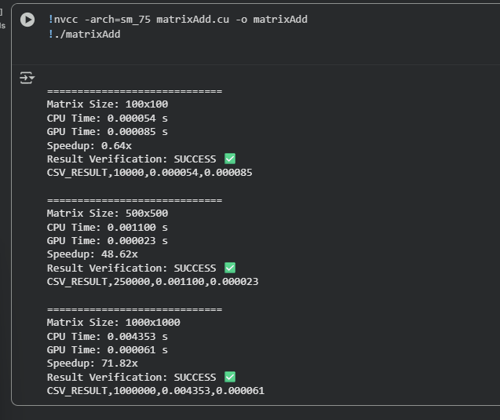

________________________________________
Problem statement 7: Dot Product of Two Vectors using CUDA
Problem Statement: Write a CUDA C program to compute the dot product of two vectors A and B of size N. The dot product is defined as:
Details:
• Initialize the vectors A and B with random values.
• Implement the dot product calculation using both serial (CPU) and parallel (CUDA) approaches.
• Measure the execution time for both implementations with different vector sizes (e.g., N = 10^5, 10^6, 10^7).
• Use atomic operations or shared memory reduction in the CUDA kernel to compute the final sum.
Task:
• Calculate and report the speedup for different vector sizes.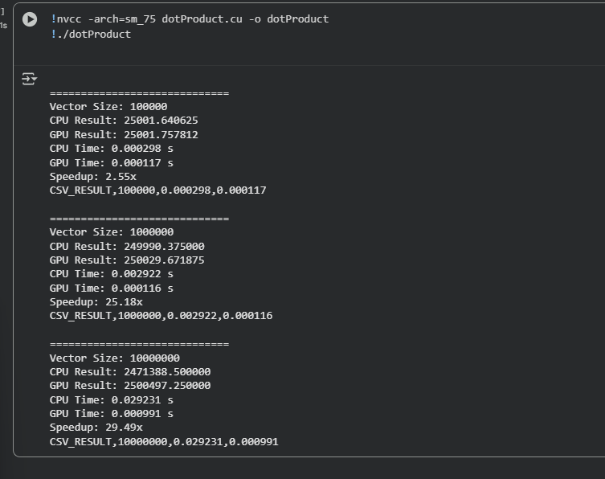
______________________________________ __
Problem statement 8: Matrix Multiplication using CUDA
Problem Statement: Write a CUDA C program to perform matrix multiplication. Given two matrices A (MxN) and B (NxP), compute the resulting matrix C (MxP) where:
Details:
• Initialize the matrices A and B with random values.
• Write code for both serial (CPU-based) and parallel (CUDA-based) implementations.
• Measure the execution time of both implementations for various matrix sizes (e.g., 100x100, 500x500, 1000x1000).
Task:
• Calculate the speedup by comparing the CPU and GPU execution times.
